Mendelian Genetics Pt II Notesheet
Name: Hour Date:
- Incomplete dominance occurs when
- If a red flower and a white flower have offspring, and both red and white are incompletely dominant, their
offspring will all be
- How do Punnett Squares change with incomplete dominance?
- In co-dominance, multiple traits can be
- What is “Roan”?
- How does incomplete dominance differ from co-dominance?
- How do Punnett Squares change with co- dominance?
- In the space below, create a Punnett Square for body color for co-dominance and another for incomplete dominance.

- In blood, which kind(s) is dominant? Which kind(s) is recessive?
- If you inherited Type A from your mother and Type O from your father, what kind of blood would you have?
- The only way to have Type O blood is
- Complete the Punnett Square below. On the right, describe what kinds of blood type are possible in this arrangement.
I^{A} i
I^{B}
i
- Explain why Type O is the universal donor:
- Explain why Type AB is the universal recipient:
- Your genes do not operate in from each other. The expression of
can affect the of another gene.
- Define Epistasis:
- The pollen of one squash is used to fertilize another squash. The parents have genotypes WWgg and wwGG. What colors will the offspring exhibit and in what ratios?
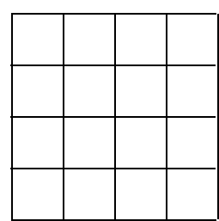

Unit Wrap-up
Name: Hour Date: Group #
- Write the three topics that you found easiest to understand in this unit:
_
_
_
- Write the three topics that you found least easy to understand in this unit:
_
_
_
- What are 2-5 things you will need to study most before taking your next quiz?
_
_
_
_
_
- Write 2-5 questions that are related to the material?
_
_
_
_

