Plant Science
Germination
Study Questions
- What is a seed?
- What are the three basic parts of a seed?
- What are the requirements for germination?
- What are the steps in germination?
- Label the parts of a Monocot seed
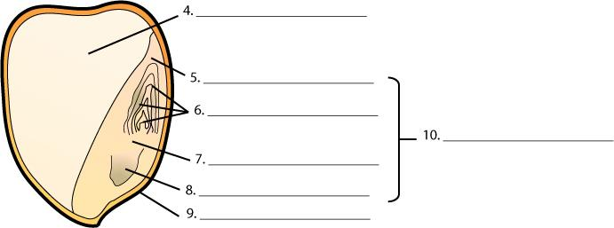
- What is the function of:
  - Seed Coat
  - Endosperm
  - Embryo
  - Cotyledon
  - Epicotyl
  - Hypotcotyl
  - Radical
- Label the parts of a Dicot seed
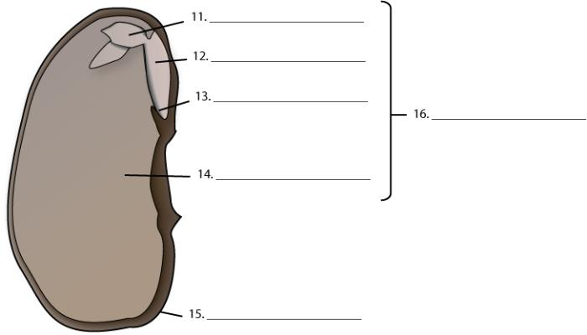
- What is the function of:
  - Seed Coat
  - Two Cotyledons
  - Epicotyl
  - Hypotcotyl
  - Radicle
- What are the processes of germination and emergence in monocot seed?
- What are the processes of germination and emergence in dicot seed?

