Agenda
August 26, 2014
Old Business:
FFA Chapter Officer Retreat
Ranchers Roundup
New Business:
September month = Colton & Matt
Activity request/fundraising/trip request forms/boards
Football Concessions
PO’s
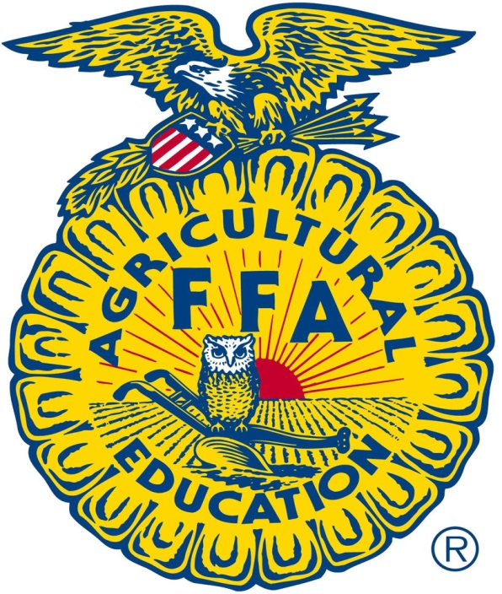
Schedule of officers and students
Back to school BBQ, Sept 9
PO’s/officer food
GH parent meeting, admin
Greenhand Conference
Reg Due date
Nationals
Registration/schedule
Freshmen workshops
Calendar- put on the website
Officer pics and bios for website\
Officer reports due 9-2
POA due dates

